**Cybershoes Quest SDK For UE4**

**The Brute Force method**

In most cases this works. Cybershoes output a single joystick press for entering sprint mode. Only disadvantage is that you cannot specifically control the speed nor the walk/run mechanism.

How to do it:  
**Engine Input > Axis Mappings   
* add Gamepad Left Thumbstick to your Y-Axis and X-Axis Mappings  
* add Gamepad Left Thumbstick Press to your Sprint Actions**

Ein Bild, das Text enthält.

The Cybershoes receiver outputs a left stick x/y gamepad signal relative to the HMD orientation. This signal tells the game in which direction the shoes are moving.  
  
Walking in the direction of the shoes works well, if the same factor is applied for speed y (forward) as for speed x (sidewards). Either you or we test how the speed feels.  
  
**Cybershoes users know** that they should select HMD oriented movement in the game settings. They press calibrate on the receiver at the start of each session to enter the follow Cybersheos mode.

**Blueprint method**

**Locate your Motion Controller Pawn (or First Person Character) Blueprint**

Right click>type **Gamepad Events**> choose Gamepad Left Thumbstick X-Axis  
Right click>type **Gamepad Events**> choose Gamepad Left Thumbstick Y-Axis

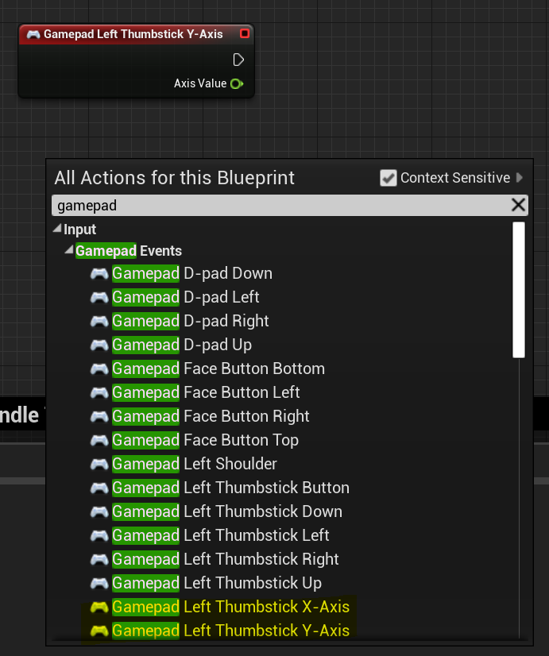

Out of your **Camera**, drag Get Forward Vector… and repeat with Get Right Vector

Use **float * float** to bring up multiplicator to adjust speed (use same value for X & Y !!)  
Wire up like below with **Add Movement Input**

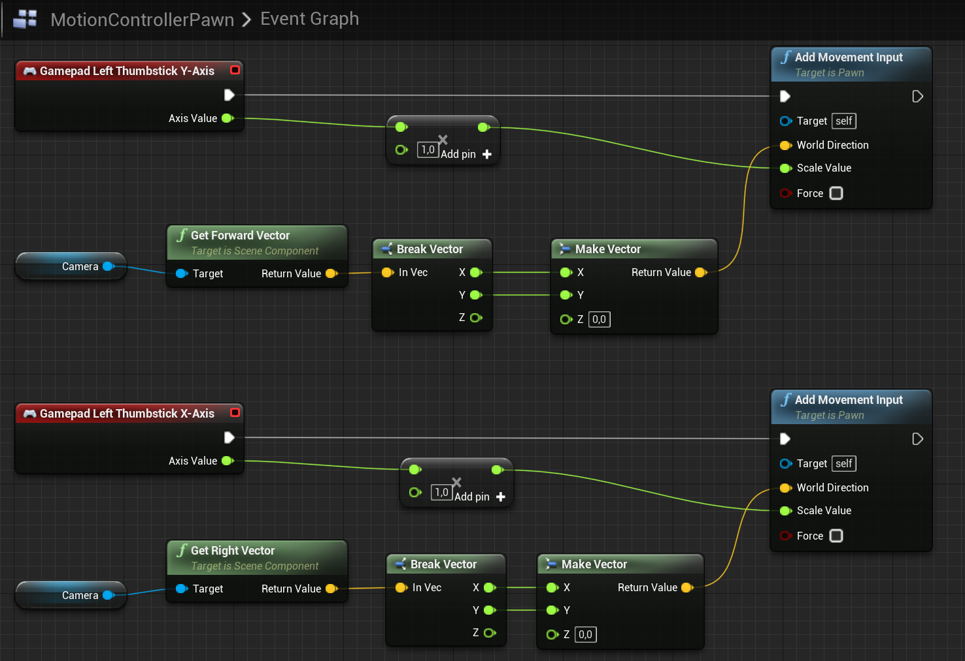

Cybershoes users are mostly nerved by “artificially” imposed stamina and “run/walk” barriers.